Exercise 5

Draw a UML diagram for a food ordering system Systems. The activities of the food ordering system are listed below. Receive the Customer food orders, Produce the

customer ordered food, Serve the customer with their ordered food, collect payment

from Customers, Store customer payment details, Order Raw Materials for food

products, Pay for Raw Materials and Pay for Labour.

Aim:

To design a UML diagram for a Food Ordering System that models the interactions between customers, restaurant staff, and suppliers while managing orders, payments, and raw materials.

Procedure:

Step 1: Identify Key Actors

Customer: Places food orders, makes payments.

Chef: Prepares the ordered food.

Waiter: Serves the food to customers.

Cashier: Collects customer payments and stores payment details.

Manager: Oversees restaurant operations, orders raw materials, and pays for expenses.

Supplier: Provides raw materials for food production.

Step 2: Define Use Cases for Each Actor

Customer

Browse Menu

Place Order

Make Payment

Waiter

Receive Customer Order

Serve Food

Chef

Prepare Food

Cashier

Collect Payment

Store Customer Payment Details

Manager

Order Raw Materials

Pay for Raw Materials

Pay for Labour

Supplier

Deliver Raw Materials

Step 3: Draw UML Diagrams

Use Case Diagram (Shows interactions of actors with the system).

Class Diagram (Defines objects like Order, Menu, Customer, Payment, Raw Materials).

Sequence Diagram (Represents the step-by-step process of food ordering and payment).

Activity Diagram (Illustrates the workflow of ordering, preparing, and serving food).

OUTPUT:

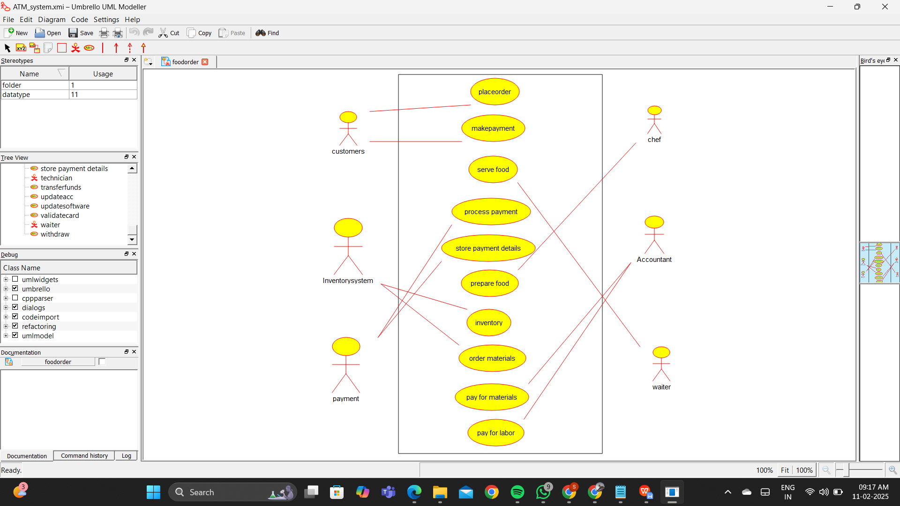

Result:

Thus the UML diagram has been implemented successfully.